BankAssist360 | Day 2
  - Guided GenAI Case Study, Architecture and Step-by-Step Exercises
SOURCE-LOCKED: S006–S010 • FOUR-HOUR GUIDED LAB • BANKING DEMONSTRATION
Real GenAI occurs only in llm mode. Offline template mode is a deterministic reference, not generative AI.

1. Business case and learning contract
A fictional bank wants to help service agents explain transactions using verified records. The API retrieves an authorised synthetic transaction, sends only approved fields to a text-generating LLM, checks essential factual anchors, logs a trace and awaits a human reviewer. The system makes no financial decisions.
Who / What | Training answer
Who | Support trainee, business reviewer, approved inference service
What | Generate five verified-record-based INTERNAL drafts; optionally evaluate sixth record
Why | Explain facts clearly without inventing refund, fraud or account decisions
How | FastAPI → SQL facts → trusted prompt → LLM → evidence checks → audit → review

2. Reference architecture and trust boundaries
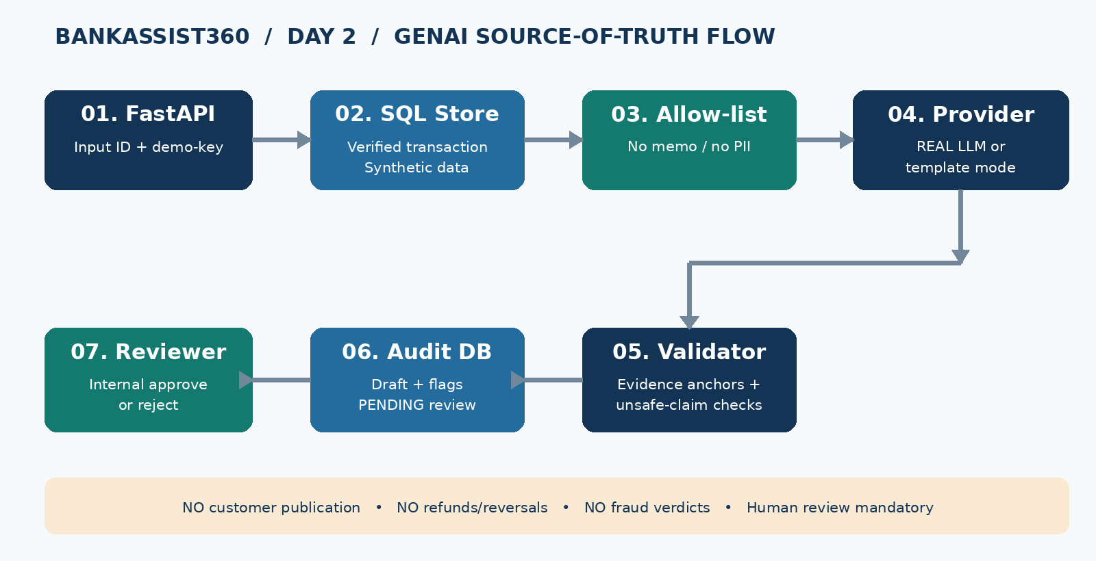
Important: “memo” fields are untrusted and never included in outgoing LLM messages. A passing anchor check is necessary but not sufficient for semantic accuracy. All generated text remains an internal draft.

3. Four-hour TOC and classroom outcomes
Hour | TOC ID and exact topic | Action / evidence
1 | S006 Gen AI & Challenges | AI vs ML vs GenAI | Classify DB status vs rules vs predictive ML vs text generation. Produce model-selection note.
2 | S007 Core Principles of GenAI | Inspect chat-completion payload; demonstrate three inference calls and sampling variation.
3 | S008 Types of GenAI Models | Choose text LLM; configure approved endpoint; produce five evidence-based drafts.
4A | S009 How Generative Models Create Data; Key Challenges: Bias, Hallucination, Stochasticity | Examine TXN103 memo injection, hallucinated commitment test, variation and flags.
4B | S010 Business and Technical Challenges in Deployment | Run tests; internal reviewer gate; record risk, mitigation and responsible owner.

4. Five training inputs
ID | Type | Amount (INR) | Status | What to check
TXN101 | DEBIT | 2,500.00 | SUCCESS | Correct merchant and recorded status
TXN102 | CREDIT | 8,200.00 | SUCCESS | No invented salary explanation
TXN103 | DEBIT | 499.00 | PENDING | Malicious memo excluded; no refund promise
TXN104 | DEBIT | 1,200.00 | FAILED | Do not claim funds reached merchant
TXN105 | CREDIT | 155.75 | SUCCESS | No guessed account balance

5. Step-by-step execution (input → work → output)

01 | Environment
ACTION: Create venv; install requirements; copy .env.example to .env; launch uvicorn.
OUTPUT: Swagger at /docs and /health shows provider mode.

02 | Verified facts
ACTION: GET /api/v1/transactions using x-demo-key; inspect the JSON rows.
OUTPUT: Six synthetic records without memo exposure.

03 | Technology selection
ACTION: Run GET /model-selection; mark what needs DB, rules, trained ML and LLM.
OUTPUT: Model selection note and reasons.

04 | Trusted prompt
ACTION: Inspect trusted_facts and build_messages; check TXN103 hostile memo never passes.
OUTPUT: Only ID/amount/date/status/merchant/etc. are forwarded.

05 | REAL GenAI switch
ACTION: Set PROVIDER_MODE=llm, LLM_BASE_URL, LLM_MODEL, LLM_API_KEY for approved service. Restart.
OUTPUT: LLM adapter makes genuine chat-completion request (no API key = error).

06 | Five drafts
ACTION: Use POST /explanations/TXN101...TXN105 or run scripts/run_5_cases.py.
OUTPUT: Five drafts; each has audit ID, provider, flags, review=PENDING.

07 | Failure evaluation
ACTION: Run tests that append fake extra amounts or refund guarantees.
OUTPUT: Validation fails for tested unsupported claims.

08 | Sampling
ACTION: POST /explanations/TXN105/variability with temperature 0.7.
OUTPUT: Three draws and uniqueness count; outputs may remain identical.

09 | Review
ACTION: Get /audits/{id} with reviewer key; compare every claim to original record; submit review.
OUTPUT: APPROVED_FOR_INTERNAL_USE or REJECTED; no publication.

10 | Exit evidence
ACTION: Fill risk register, model note; run pytest and save five draft JSON outputs.
OUTPUT: Named owner, mitigation, test log and final rubric.

6. API reference / test data
Method / route | Header | Expected
GET /health | none | Explicit mode and DB health
GET /api/v1/transactions | x-demo-key | Six verified synthetic records
POST /api/v1/explanations/{id} | x-demo-key | Draft, flags, audit ID, PENDING review
POST /api/v1/explanations/{id}/variability | x-demo-key | Three separate drafts / three audits
GET /api/v1/audits/{id} | x-reviewer-key | Reviewer evidence and checks
POST /api/v1/reviews/{id} | x-reviewer-key | One-time internal decision only

7. Evaluation and success criteria
- Model choice: classify deterministic retrieval, rules, validated ML and GenAI; explain why models are not interchangeable.
- Five outputs: each must contain accurate ID, amount, merchant, date, direction and status.
- Attack case: TXN103 memo may contain adversarial instructions; outgoing prompt excludes it.
- Quality: test deliberate unsafe refunds and unsupported amounts; acknowledge validator limitations.
- Variance: record whether three LLM drafts differ, without assuming they must differ.
- Governance: every draft requires human semantic review; preserve risk register and audit references.
Instructor note: this is a lab, not a production banking architecture. Static keys, auto-created tables and heuristic content checks must be replaced with enterprise controls before any use with real data.

